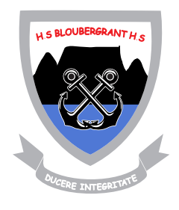
6 Curlewis Road
Bloubergrant, 7441
TEL: (021) 557 6390
FAX: (021) 557 6043
FAX2EMAIL: (086) 416 5003

Hoërskool
BLOUBERGRANT
High School

WESTERN CAPE EDUCATION EMIS REGISTRATION 0103008009

Dear Parent / Guardian

PERMISSION LETTER FOR MEDIA

In order for Bloubergrant High School to use any and all forms of media of any learner at any school affiliated occasions and events, such as, sports matches, culture productions, excursions and other related school activities – parental permission must be obtained.

PLEASE NOT THAT FAILURE TO COMPLETE AND RETURN THE REPLY SLIP WILL RESULT IN NON-EXPOSURE OF THE LEARNER AT ANY AND ALL EVENTS PUBLISHED.

I understand that the images / videos may be used in print publications, online publications, presentations, websites, and other social media platforms affiliated to Bloubergrant High School. I also understand that no royalty, fee or other compensation shall become payable to me by any reason of such use.

The form of media used will be done in good taste and merely to share or promote the activities done by learners at Bloubergrant High School.

Yours in Education,

_______________
M.H.S. Pedro
HEADMASTER

Reply Slip for: PERMISSION LETTER FOR MEDIA

I, _______________________________________________ ID ________________________

Please X your preferred response

Give Permission

“In order for Bloubergrant High School to use any and all forms of media of any learner at any school affiliated occasions and events, such as, sports matches, culture productions, excursions and other related school activities – parental permission must be obtained.”

Do Not Give Permission

Should you choose “do not give permission” you will be giving no-exposure of the learner to all events published.

Parent / Guardian Name: _______________________________________________________

Child’s Name: ______________________________________________ Grade: __________

Date: _______________ Phone Number: __________________________________________

